**Objective:-** Deploy todo app/expense app on any free portal.

**Steps :-**

1. 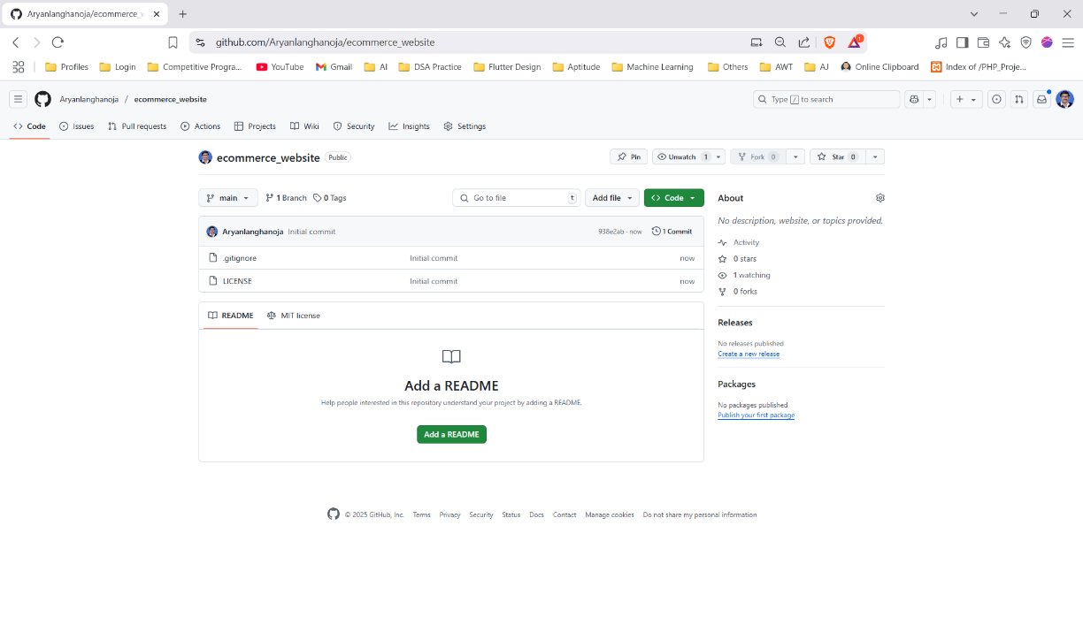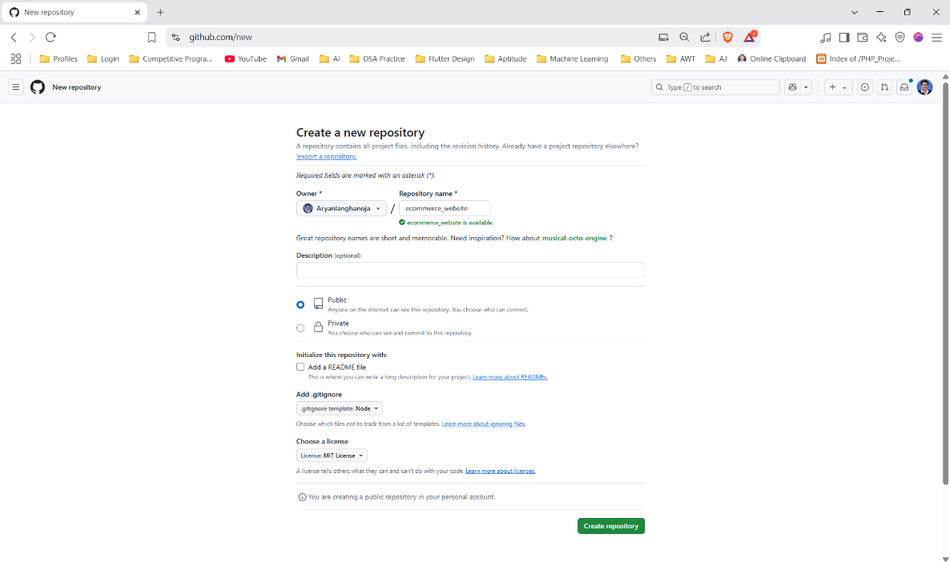Make A GitHub Repository and Put all Your Project files into it. Make sure you set Visibility as Public.

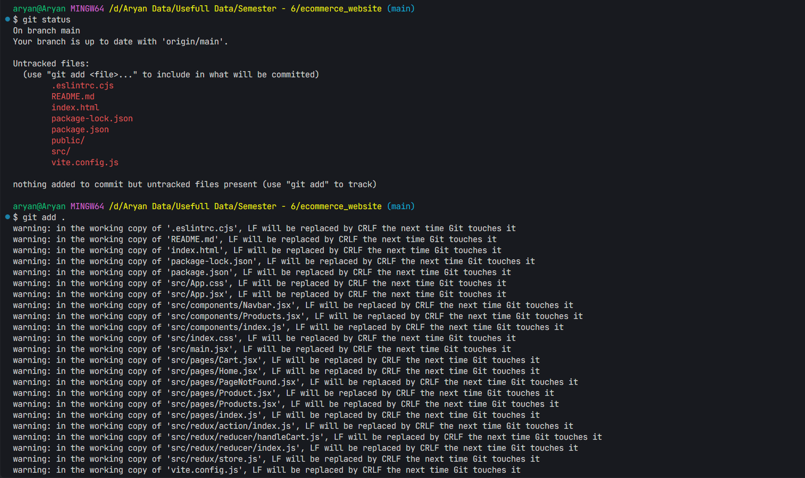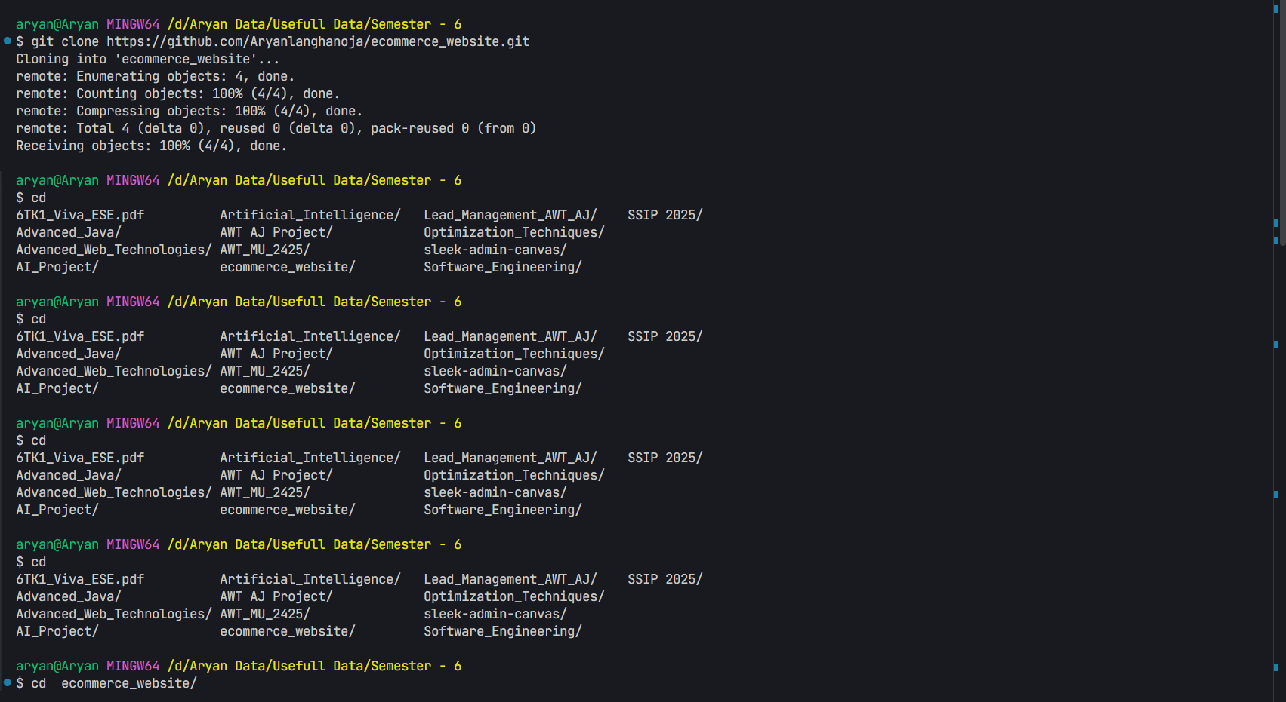

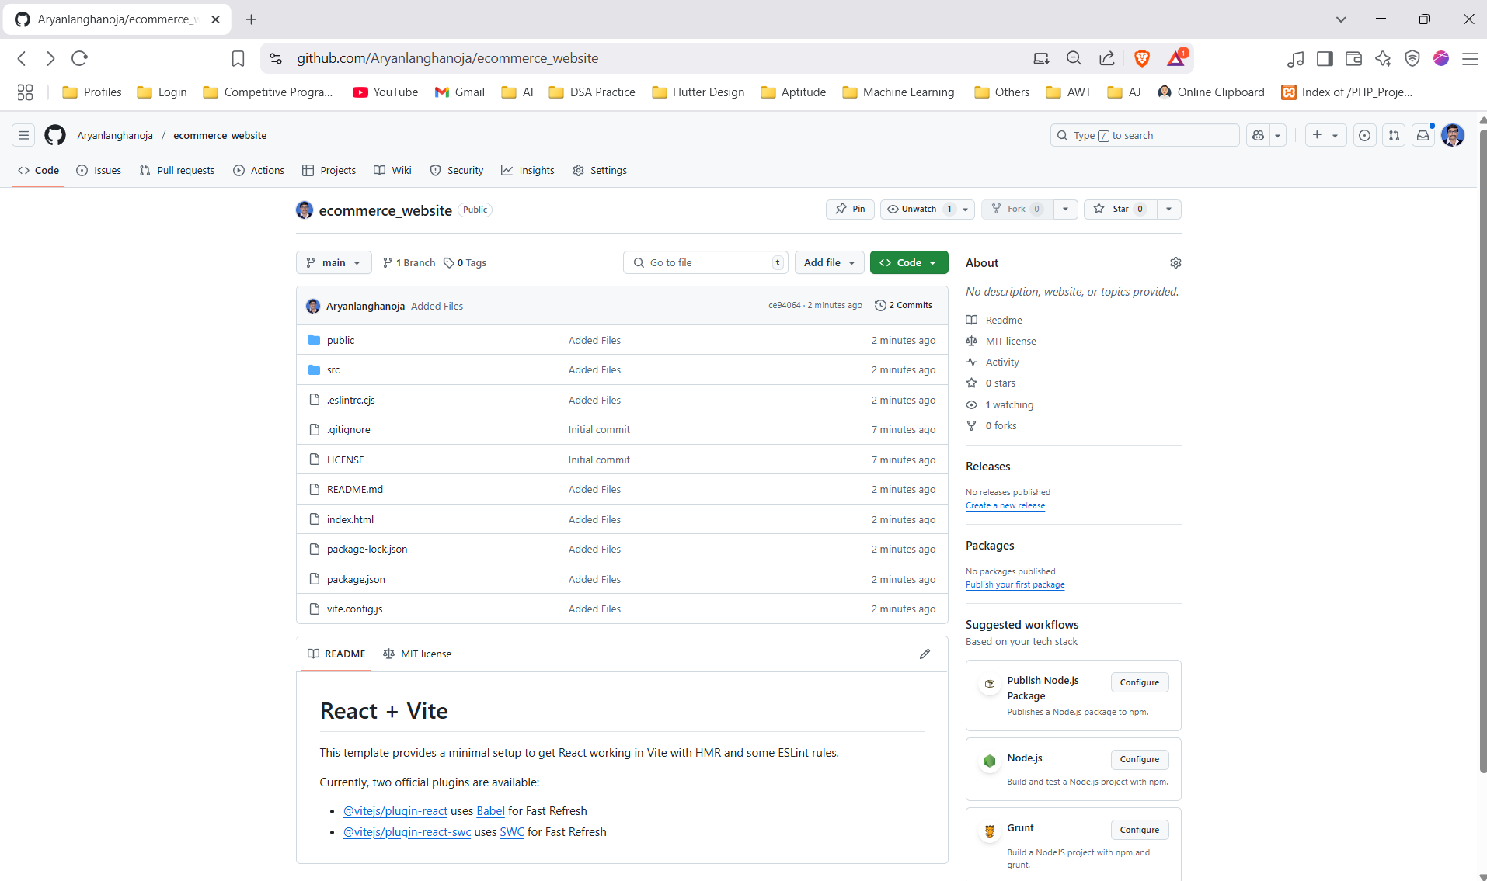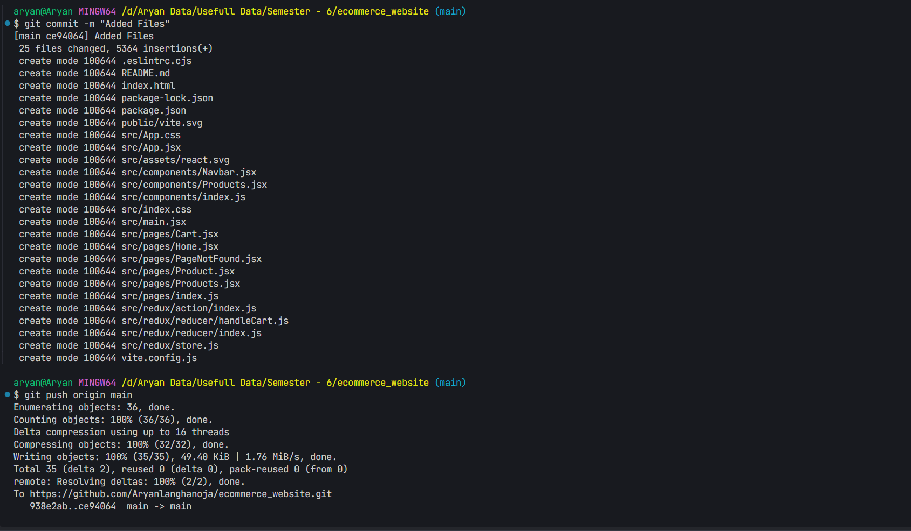

1. 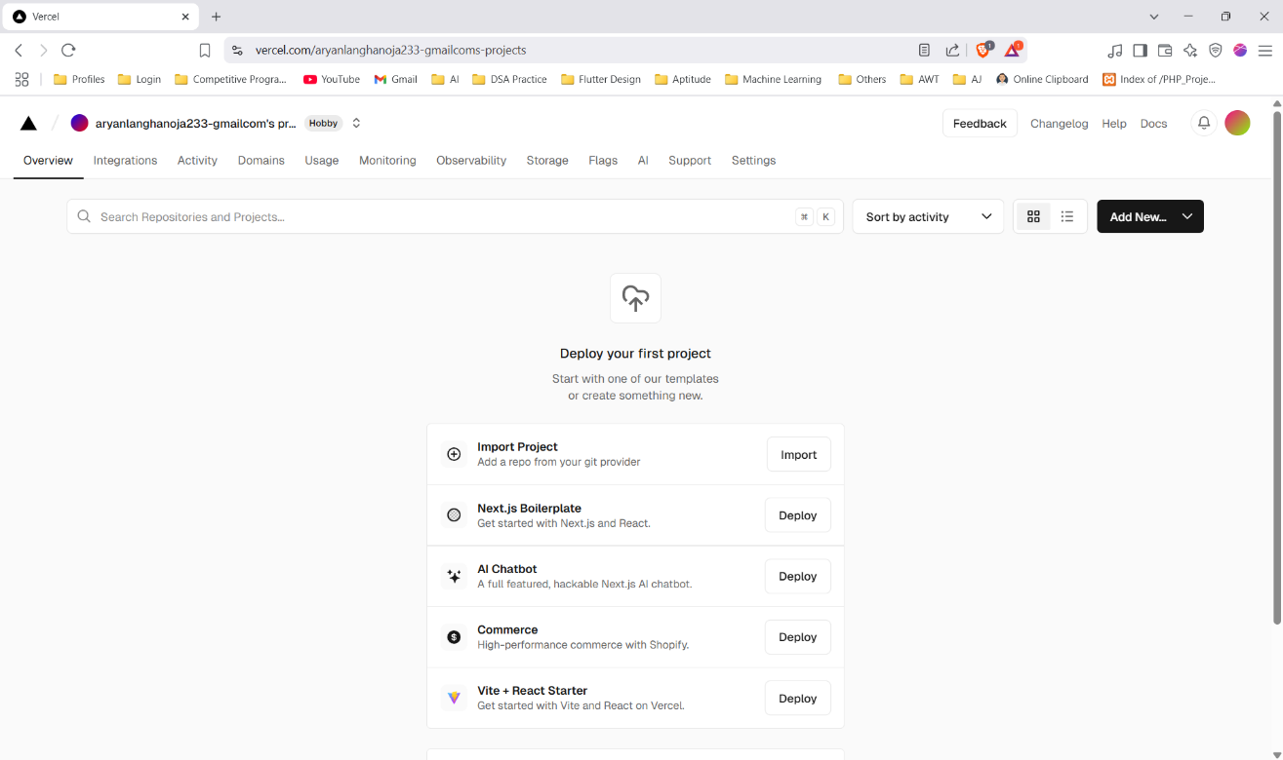**Create account on vercel and and login and authenticate your github with your vercel account. After successful authentication you will be having the dashboard.**
2. 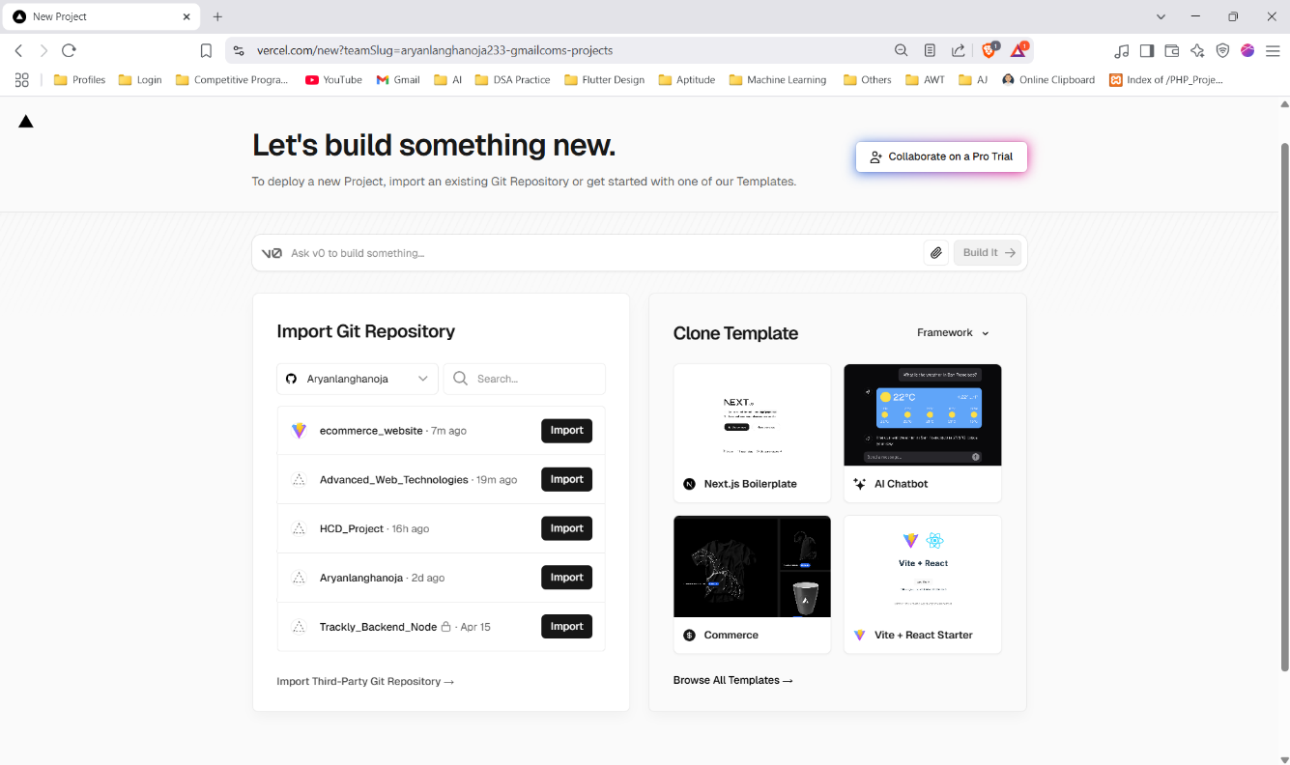**Press Add New Project and press import from github.**
3. 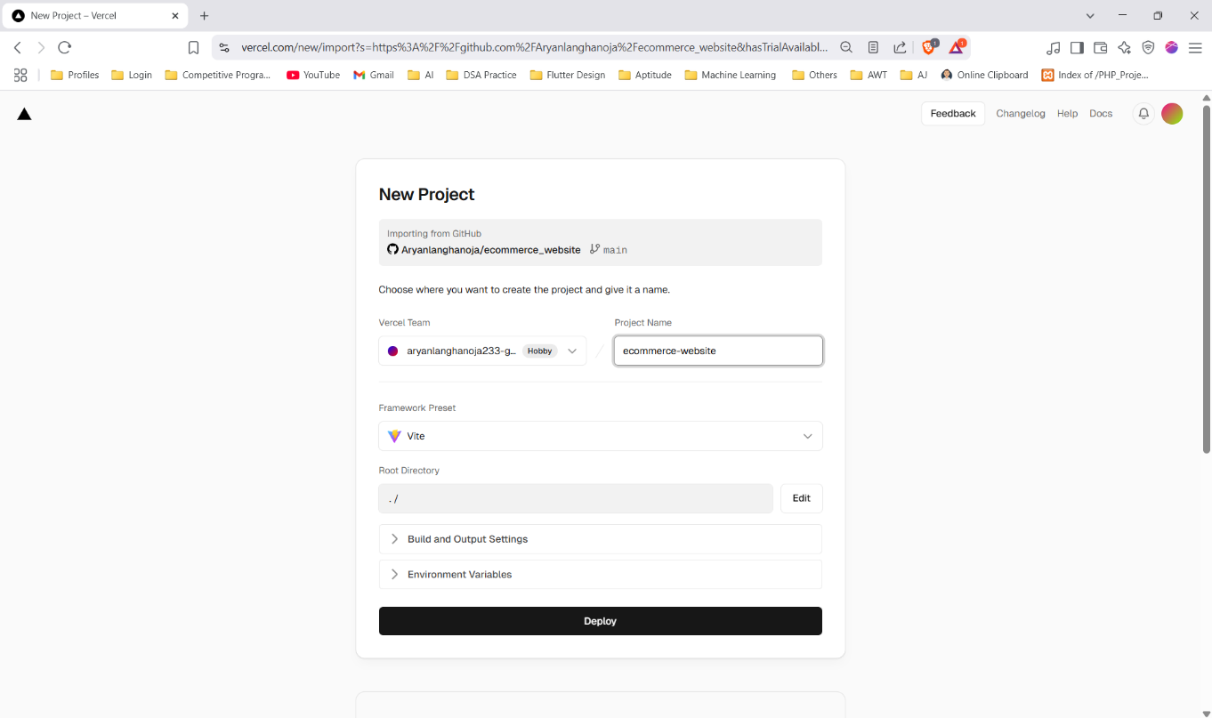**Select The Repository You had made previously and hit deploy make sure you provided the correct path of root directory**
4. **The Process is Started**
5. 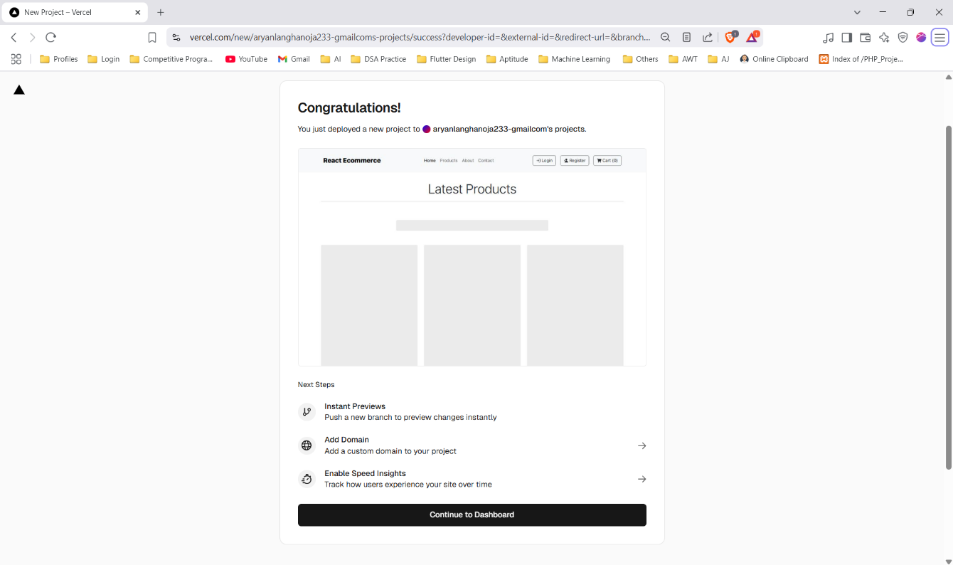**After the Successful Deployment you will be getting the screen.**
6. **You will be getting the details page**

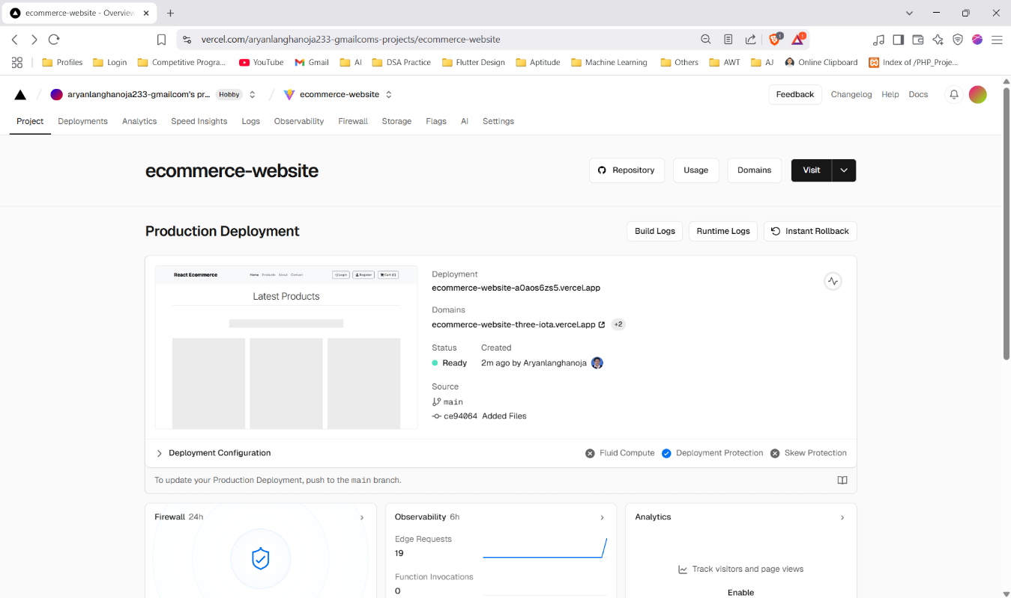

1. **Hit on the domain URL is the live link of your project.**

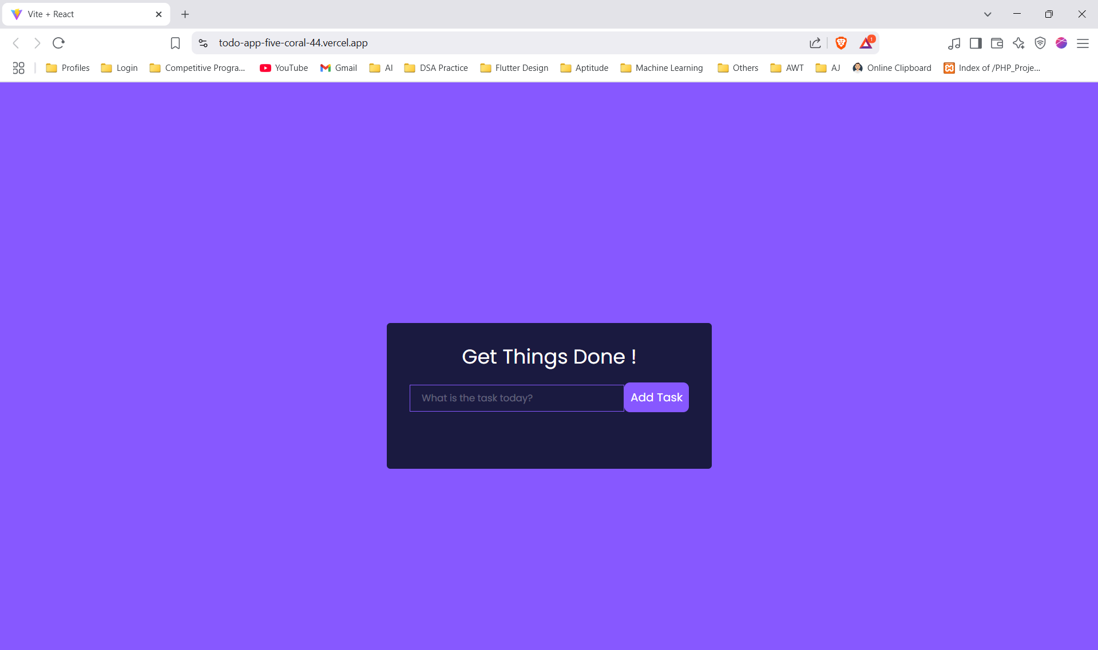

**Live Link :-** <https://todo-app-five-coral-44.vercel.app/>